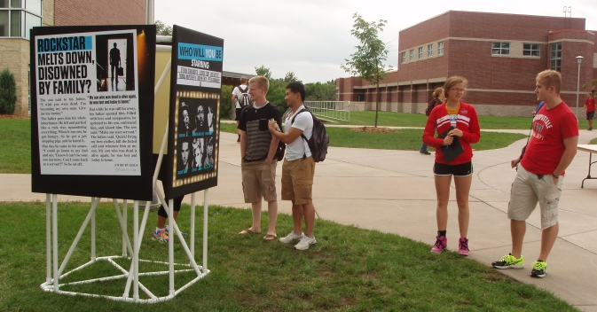
Why a kiosk?
- Visibility – at least one panel can be seen from any direction
- Focus – proxe participant is not distracted by other panels or people
- Intrigue – curiosity raised by unknown of what lies ahead
- Space – room for multiple people at a panel at one time

Why use Schedule 40 PVC?
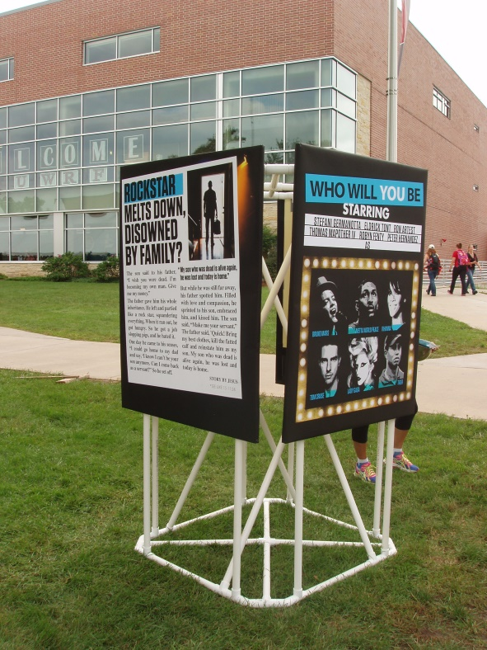
- weight – individual parts are lightweight to carry and assemble, but, when assembled, the kiosk structure is heavy enough to withstand high winds
- good strength
- weatherproof
- easy to assemble and disassemble
- low to moderate cost
- easy to cut/alter/paint (as desired)
- low maintenance and longevity – won’t rot, rust, or decay

Materials
- (12) – 1 in. x 10 ft. PVC Schedule 40 pipe
- (32) – 1 in. Schedule 40 PVC Tee
- (16) – 1 in. Schedule 40 PVC 45-degree Elbow
- (2) – 1 in. Schedule 40 PVC Cross
- (1) – VELCRO Brand 4 ft. x 2 in. Industrial Strength Tape
- (2) – 1 in. x 4 ft. x 8 ft. insulation sheathing
- (1) – roll of black duct tape

Construction
- Take (4) of the 10 ft. pipes and cut an 83 in. section off one end and a 24-1/2 in. section from the other end. The 83 in. sections will be vertical diagonal braces and the 24-1/2 in. sections will be base cross braces. Set the remaining length of each of the 4 cut pipes to the side for now.
[TIP: mark the measured length on the PVC pipe with a Sharpie marker]
[TIP: use a miter saw to make all PVC pipe cuts]
- Take (4) of the 10 ft. pipes and cut a 72 in. section off one end and a 24-1/2 in. section from the other end. The 72 in. sections will be columns and the 24-1/2 in. sections will be base cross braces. Set the remaining length of each of the 4 cut pipes to the side for now.
- Take the remaining (4) 10 ft. pipes and cut a 72 in. section off one end, and two 20-1/2 in. sections from the other end. The 72 in. sections will be columns and the 20-1/2 in. sections will be base sides. Set the remaining length of each of the 4 cut pipes to the side for now.
- From the (12) leftover sections (of varying lengths) of pipe that were set aside earlier, cut (40) 1-1/2 in. pieces. These will be connector pieces between the PVC Tees and Elbows.
- At this point you should have the following sections of PVC pipe:
Cut sections Purchased connectors
A = (40) 1-1/2 in. connectors F = (32) Tee connectors
B = (8) 20-1/2 in. base sides G = (16) 45 degree elbow connectors
C = (8) 24-1/2 in. base cross braces H = (2) Cross connectors
D = (8) 72 in. columns
E = (4) 83 in. vertical diagonal braces

Assembly
- Assemble two “bases” as shown in the diagram below:
[NOTE: On one end of each base side “B” there are 2 tees (“F”) and on the other there is just 1. For one base put the extra tee on the left end of each base side and for the other base put it on the right side.]
[TIP: twist the PVC pipes/connectors when pushing them together]
[TIP: the “A” connectors should not be visible when bases are assembled, half of each being inside the tee/elbow it is connecting]

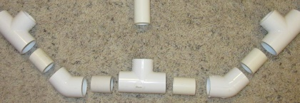
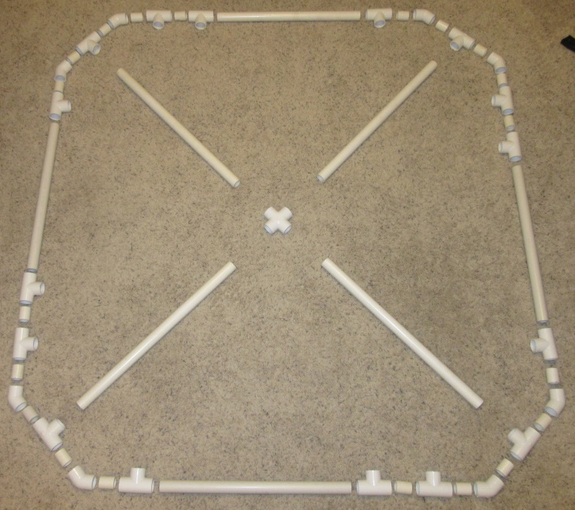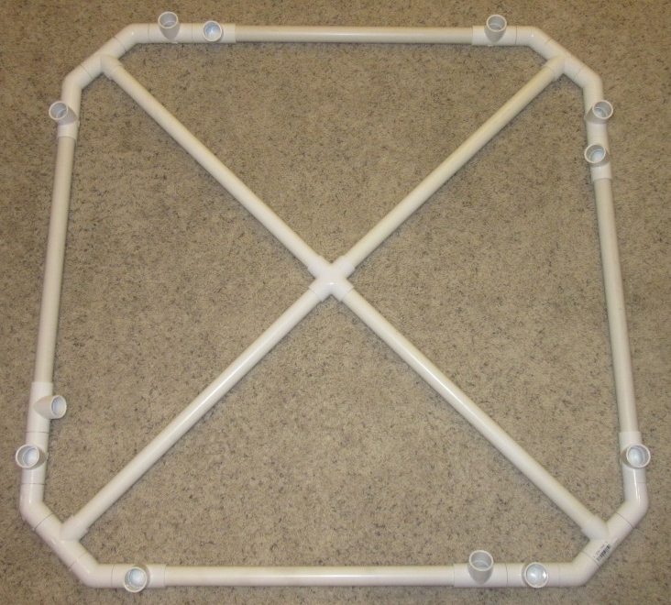
F C F
A G A F A G A

CORNER (TYP OF 4)

H

C C

A F B F A F A

- Insert the 8 columns (“D”) into the 8 tees (“F”) closest to the corners of one assembled base.
- Set the second assembled base on top of the 8 columns, gently inserting each column into a tee (“F”) closest to the corners of the base. Do NOT tighten (insert columns all the way into the tees/base) yet.
- There should be one open tee (“F”) on each side of both the top and bottom base. Insert a vertical diagonal brace (“E”) into each tee on the bottom base and twist/tighten.
[TIP: hold the brace inside the kiosk, or rest it on the opposite side of the top brace while doing this]
- Now insert the top of the diagonal brace (“E”) in the open tee on the opposite side of the top base.
[TIP: begin with the tee opening horizontal so the lower side of the brace is inside the tee, then rotate the tee downward, which will cause the top of the brace to fully enter the tee opening]
- Now gently pull down on the top base, tightening the connections with the columns. Your kiosk should now look like the picture to the right .
- Using a utility knife, cut the 1” insulation sheathing into 4 equal sizes based on the dimensions of the printed proxe panels.
[NOTE: 2100 provides extra space on each side of the printed proxe panel, so the size of the cut insulation sheathing should be smaller than the printed panels]
- Wrap the printed proxe panels around the sides of the insulation sheathing and secure it using duct tape on the back.
- Measure and place the industrial strength VELCRO on the proxe columns and 4 corners of the proxe panels.
[TIP: the adhesive side of the VELCRO will adhere to duct tape better than to the insulation sheathing, so place duct tape on the back of the proxe panel before placing VELCRO]
- Attach the proxe panels to each side of the kiosk and you’re ready to go! Below is a picture of the top corners of the panels after being connected to the kiosk.

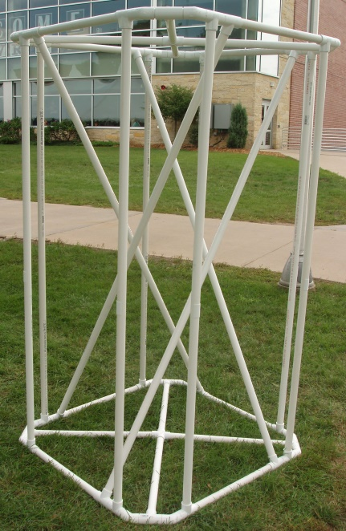
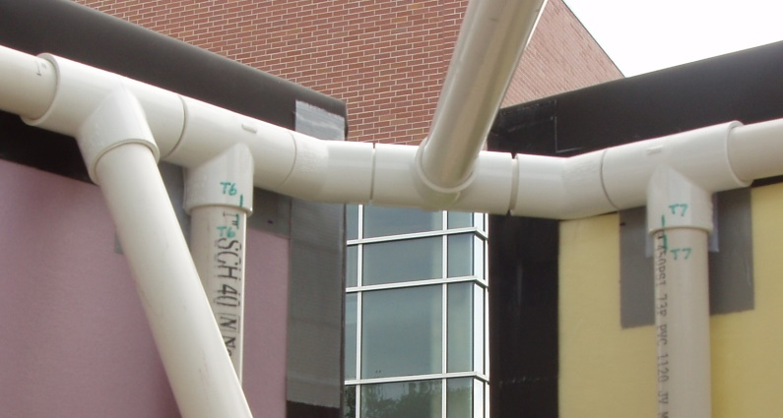

DISASSEMBLY AND TRANSPORTATION
To disassemble:
- Remove the proxe panels
- Remove the top base by pushing up or tapping on the tees above each column
- Remove the columns and diagonal braces from the bottom base by stepping on the side of the tee while twisting and pulling up on each column/diagonal brace.

To transport, keep the two bases intact. Have one person carry the two bases, another person carry the 4 panels, and two people to carry the columns and diagonal braces.

If you have any questions or ideas for improvements, please feel free to contact:
Brian Aust
(765) 414-5987
brian.aust@gmail.com

