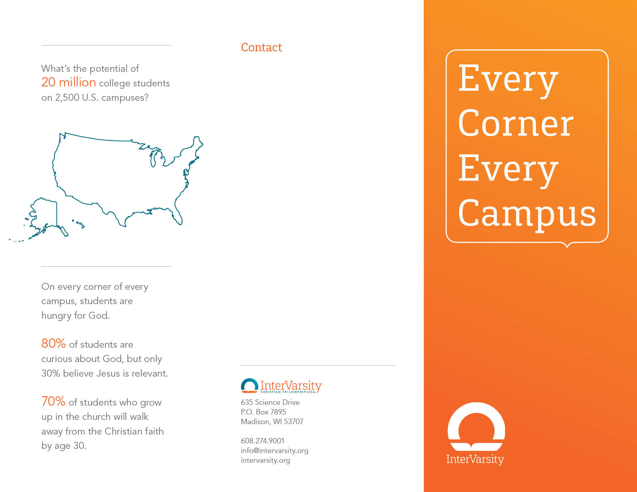
EXAMPLE:
John Doe
john.doe@intervarsity.org
999.000.1234
facebook.com/jdoebro
Twitter and Instagram
@jdoebro
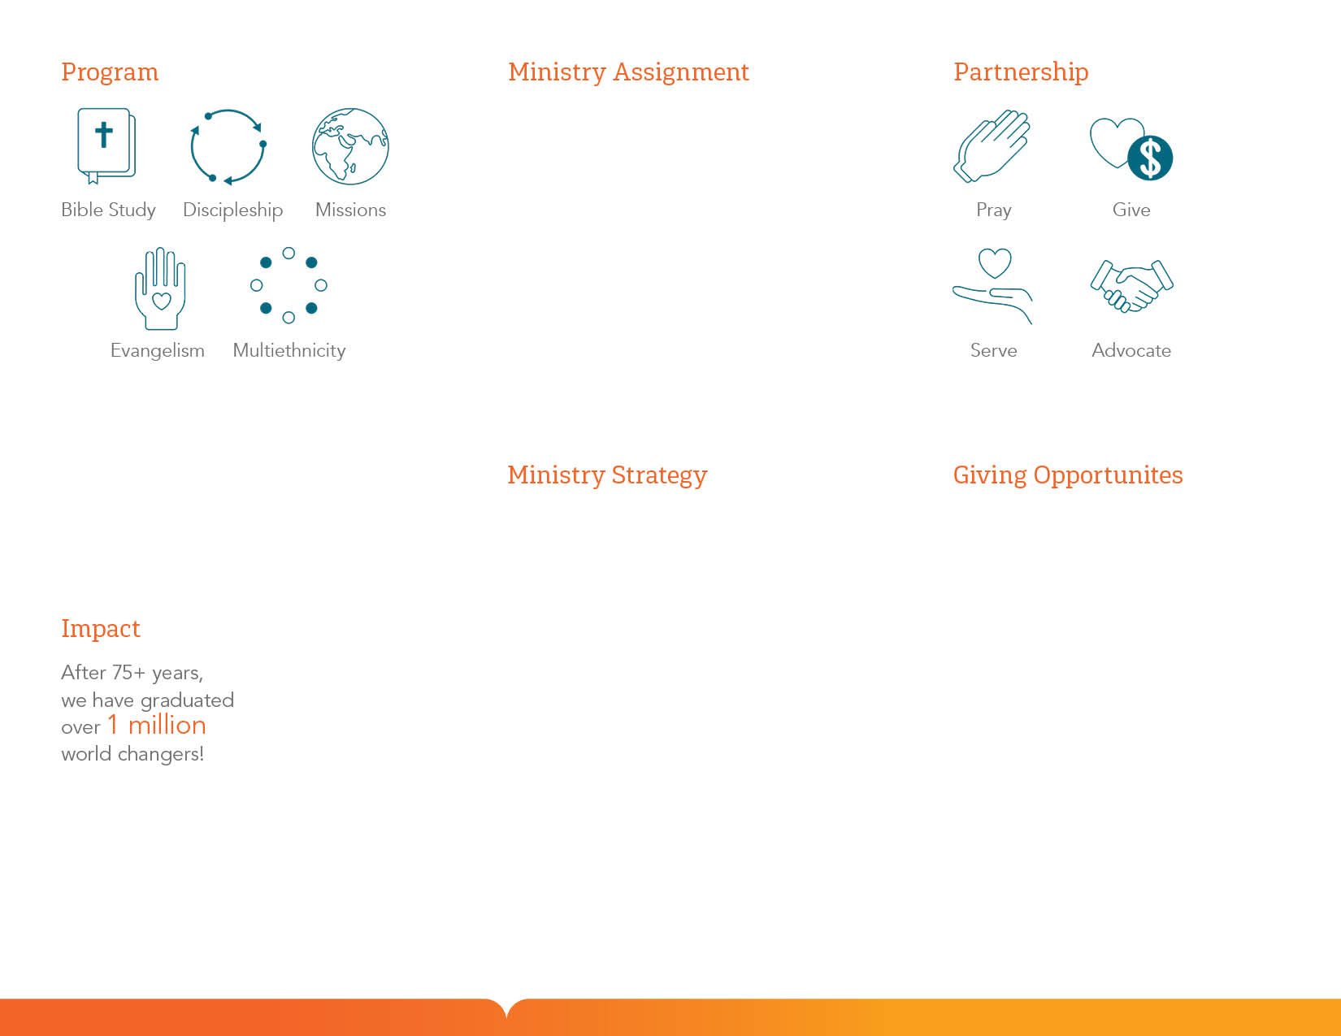
EXAMPLE:
Total Budget - $56,4000
Reach out to new students
NSO Proxe
3 new GIGSs
Develop strong disciples
Weekly large group
12 weekly small groups
2 weekend conferences
EXAMPLE:
Any additional information you wish to provide about your ministry and your role on campus
EXAMPLE:
Leadership Gifts
1 gift of $6,000 /yr
1 gift of $4,000 /yr
Supporting Gifts
2 gifts of $2,500 /yr
5 gifts of $200 /mo
Sustaining Gifts
6 gifts of $150 /mo
8 gifts of $100 /mo
10 gifts of $75 /mo

Before you print your file, make sure you delete the background photo and remove this page
Please use Avenir LT Std 55 Roman in a 70% grey for your text. If you don’t have Avenir yet, you can find it here: http://2100.intervarsity.org/resources/avenir-font
Depending on your printer, the text boxes might need to be slightly adjusted.

