Leader Notes for the “Money” campaign 2013
Discipleship Values and Small Group Notes
Beth Roselius and Doug Schaupp

Bringing our finances to Jesus and inviting him to be Lord over this part of our lives may be the most important discipleship issue we ever face. As you consider brining the “Money” campaign to your campus, you also are asking Jesus to play the central role in your financial thinking and decision-making. (See comments from Jason Jensen at the end on financial discipleship.)

BOTH PERSONAL AND COMMUNAL
This article is designed to be read and discussed through three different lenses.
- Personal. This is designed for you to reflect personally, about your relationship with God and your relationship with money. You are being invited by God to go deeper with him on these crucial discipleship issues, not just to bring these values to your Small Group. Often the most important act of leadership is to let God first speak into your life, inviting him to transform how you think and live. As you think about bringing this to your campus, please start with the question, “What is God saying to me first?”
- Your Leadership Team. If you want to bring the full “Money” campaign to your campus, you need to have strong ownership from your key partners (staff, other student leaders, etc.) Please bring this to your team and discuss this in community. Together you can consider, “How is God leading us as a community toward these Kingdom values?”
- Your Chapter and Your Campus: How can these concepts serve the other students in your community? What are their possible discipleship barriers? How can you best serve them in this process? What might they be afraid of? What might you be afraid of on their behalf? How is this campaign “good news” for your campus, for non-Christians?

FOUR KEY COMMITMENTS
After testing this campaign on several different campuses, we have created a prototype of how to construct the campaign. However, please feel free modify the small group series and the passages according to the other things God is doing in your context. We suggest that you reinforce the same core values throughout your series, so that people move from activity to deeper conviction and calling from God for a lifetime of joyful discipleship with money. (Here are four Kingdom values we borrowed from Gary VanderPol: Lazarus at the Gate, 4 key commitments.) See our worksheet below for going deeper on these values. This worksheet below is designed to be used at each of the Small Groups and Large Groups in the campaign. We think that people need several weeks to reflect on these important topics. (If you are ready to go deeper, please read and discuss Gary’s full 31-page article.)

Discipleship Worksheet

§ Be Grateful: Regularly give thanks for the blessing of wealth
- How can you remind yourself that food, water, air are all gifts from God?
- What is one practical thing you can do this week to remind yourself that every penny you spend is a gift from God?
- Try putting a small post-it note with the words “gift from God” on your credit card or your student meal card. Every time you swipe this week, give thanks to God for his lavish generosity.

§ Do Justice: Live a life of compassion and solidarity with the poor around the globe.
- Ask God to give you a heart for a community of people locally and another community of people internationally. Ask God to break your heart for them.
- Find ways to love them practically and to learn from them.
- Decide on an intentional personal standard for how much of your wealth is for sharing ($50, 000 per year is the upper 1% of the worlds’ most wealthy. See globalrichlist.com)

§ Live Simply: Make one lifestyle change in order to buy less for personal consumption
- Discuss with your Small Group, “What is one thing we consume that we could do without for a week, month, or year?” (See if your Small Group can come to consensus on consuming less of something, so that you can be generous together.)
- Create a simple living list of things you might be able to live without. For example, buy no new clothes for the semester or the year. Or drink no Starbucks for a month. Or don’t go to a movie theater for the year.
- Consider drinking only tap water during the campaign. Set aside the money you would have spent on beverages and give it to Swaziland or another community on your heart.

§ Act Generously: Make a substantial gift to fight global poverty
- Make a one-time special gift toward:
- A country, cause, or trusted ministry
- Schedule regular times to serve/love the poor in our midst
- Every 2 weeks, make time to feed the homeless, tutor children, etc
- Consider committing extended time to identify with the poor.
- Ask God to speak to you about your Spring Break or Summer Plans.

OVERVIEW OF FOUR SCRIPTURE PASSAGES:
STEPPING STONES TO TRANSFORMED LIVES
These four passages offer us Good News both for our own discipleship journey, and for
the non-Christians around us. (Feel free to exchange these with other passages that make more sense for your context.) The following flow of passages combines Small Group, Large Group , and a training meeting.

- Luke 12.22-34. Small Group. By bringing up the question of anxiety, people will see how Jesus’ teaching on money bring them peace and joy. After teaching the passage, please pass out the above worksheet. (This passage particularly addresses Be Grateful and Act Generously.) Please cast vision for how they can take risks and participate in the upcoming campaign.
- Luke 12:13-21. Large Group. Please dig into the passage that also appears on the Money proxe. Explain how this passage sheds light on how we can Be Grateful, Do Justice, Live Simply, and Act Generously. (After you teach on this passage, please train everyone at Large Group on the first 3 panels of the proxe. Have them practice in pairs. After the Large Group, please offer another training on the 4 circles gospel summary. The 4 Circles is complex enough to require its own training slot.)
- 3. Luke 16:19-31. Small Group after the Proxe on campus. This passage is Good News both for the rich and poor, for Christians and for Non-Christians. Please offer a call to response at the end of Small Group. This passage flows well into points two, three and four: Do Justice, Live Simply, and Act Generously.
- Matt 2: 25-46. Large Group and Kit Build. This passage is good news to the poor and to the rich. It points us toward Doing Justice, Living Simply, and Acting Generously. Please see our “Sample LG Talk” on Matt 25 for ideas on a call to faith and the kitbuild.

TEACHING NOTES ON THE 4 SCRIPTURE TEXTS
We have organized our comments about each passage in three parts:
First, main points about each passage and key questions.
Second follows important teaching points, things for you to pay attention to as you get ready to teach.
Third are application questions and ideas.

Luke 12.22-34
main points and key questions:
- Anxiety. Why do we have it? Does it add anything to our lives? Does it get us anywhere? How is anxiety connected to little faith? Why are children of God not supposed to be anxious? How can we not worry?
- Your value and God’s provision. Do you believe God will feed you and provide for you? Do you believe you are this valuable to God? When we feel anxiety, we doubt God’s provision for us, and we doubt our value to God.
- Heart and Treasure. Do not set your heart on stuff. Set your heart and priorities on the Kingdom first.
- Practice freedom. Do something about it. Sell possessions. Enjoy your freedom from materialism.

Teaching Points
- How can you help people identify their anxiety: Write down a time you were anxious this week. Did it help you?
- Can you see how your anxiety is a form of unbelief in the goodness of God?
- Where your treasure is there your heart will be also. This direct correlation is one of the hardest things for American Christians to believe about ourselves. We want to see our hearts as free from materialism without getting rid of anything. But we call Jesus a liar when we think of our hearts this way.
- Kingdom first. Great way to call people to the campaign. Live Kingdom first. How is this good news that we are bringing to campus?

Application
- What do you love about this passage?
- Hand out the 4-point Discipleship Worksheet and ask people to fill it out.
- Practice freedom tonight. We have to actually do this. They need to go to their closet, grab a clothing item or video game that they value, and give it to the poor (or anyone). You might want to gather up the “treasure” and donate to Salvation Army.
- Invite them to the LG to hear about the campaign, and to get trained on the proxe. Ask them to invite a few friends as well.

22 Then Jesus said to his disciples: “Therefore I tell you, do not worry about your life, what you will eat; or about your body, what you will wear. 23 For life is more than food, and the body more than clothes. 24 Consider the ravens: They do not sow or reap, they have no storeroom or barn; yet God feeds them. And how much more valuable you are than birds! 25 Who of you by worrying can add a single hour to your life[a]? 26 Since you cannot do this very little thing, why do you worry about the rest?
27 “Consider how the wild flowers grow. They do not labor or spin. Yet I tell you, not even Solomon in all his splendor was dressed like one of these. 28 If that is how God clothes the grass of the field, which is here today, and tomorrow is thrown into the fire, how much more will he clothe you—you of little faith! 29 And do not set your heart on what you will eat or drink; do not worry about it. 30 For the pagan world runs after all such things, and your Father knows that you need them. 31 But seek his kingdom, and these things will be given to you as well.
32 “Do not be afraid, little flock, for your Father has been pleased to give you the kingdom. 33 Sell your possessions and give to the poor. Provide purses for yourselves that will not wear out, a treasure in heaven that will never fail, where no thief comes near and no moth destroys. 34 For where your treasure is, there your heart will be also.

Luke 12.13-21
Main Points
- Life is more than stuff. Life does not consist of abundance of possessions. We envy people like this rich man. Donald Trump, wealthy athletes, etc. We should have compassion on them and pray for them instead.
- Our actions reflect our hearts. Whoever stores up things for themselves are fools. Our hearts will inevitably treasure the things we own.
- Invitation. The call to use our resources for others is the invitation from God to our living lives of freedom. We need this call for our own spiritual health. This passage is Good News for us.

Teaching Insights.
- No one else on campus will help students and faculty with financial freedom like Jesus will. We have good news to give! We are helping save people from just living for themselves, and treasuring the wrong things in life.
- Beware of greed. v.13-15. This man is not asking for something outrageous. He would like his “fair share” of what he should get. Even pressing for what is rightfully ours can open the door to our greed.
- “We are the 1%”. Rich people are not out there. Anyone with a college education and making more than 50K per year are the top 1% of the internationally wealthy, by global standards. This passage is a warning for us, not for someone else. Most college graduates will eventually make more than 50K per year.

Training students to use this passage in proxe conversations.
1. “How is this good news for you personally?” Help each student find something in the story that they love. They will lead the proxe better if they have internalized the passage as good news for themselves.
2. Does the man just die, or does God kill him? The text does not say. As we teach this on campus, if we are asked about this, your students can answer it however they wish. One student said, “The story is not clear about why the man dies. I personally think it was just his time to die.”

3. We are not using v.13-15 in the proxe. We hope this will not confuse our students. Please explain to them that had to keep it focused.
4. You may want to prep your students for panel 2 of the proxe. Here are a few background links if people wonder about how you can get water for $25 or why geese for a family:
http://www.charitywater.org/ https://secure1.heifer.org/gift-catalog/geese.html?msource=KIK2I120300&gclid=CLP287iinbQCFQLxOgodIEEA3A

Application
- How are you tempted to “build barns” for yourself?
- What are a few practical steps you can take to be rich towards God?
- Hand out the 4-point Discipleship Worksheet
- From now until the Kit-Build large group, invite students and staff to fast from all beverages except water. Instruct them to save the money that they would normally spend on these other beverages. Collect the money at the Kit-Build to give to World Vision.

Someone in the crowd said to him, “Teacher, tell my brother to divide the inheritance with me.”
14 Jesus replied, “Man, who appointed me a judge or an arbiter between you?” 15 Then he said to them, “Watch out! Be on your guard against all kinds of greed; life does not consist in an abundance of possessions.”
16 And he told them this parable: “The ground of a certain rich man yielded an abundant harvest. 17 He thought to himself, ‘What shall I do? I have no place to store my crops.’
18 “Then he said, ‘This is what I’ll do. I will tear down my barns and build bigger ones, and there I will store my surplus grain. 19 And I’ll say to myself, “You have plenty of grain laid up for many years. Take life easy; eat, drink and be merry.”’
20 “But God said to him, ‘You fool! This very night your life will be demanded from you. Then who will get what you have prepared for yourself?’
21 “This is how it will be with whoever stores up things for themselves but is not rich toward God.”

Luke 16:19-31

Gig-like questions:
- who needs mercy in this story? what does mercy look like?
- what does the rich man think he needs, and what does he actually need?
- how is this passage good news for the poor of the world?

Other Main Points and Key Questions.
- The poor are a gift from God to us to soften our hearts. Lazarus was God’s gift to this rich man to teach him compassion. By ignoring the poor, he ignored God’s invitation. Ignoring the poor goes against God’s plan. To do nothing reinforces the cycle of injustice and the brokenness in our hearts.
- Consequences for our choices. We cannot say we didn’t know. We cannot claim ignorance. The truth is that we turn our eyes from people who are hurting and in pain because it causes us discomfort. We care more about feeling good than helping others.
- The danger of valuing stuff. When we set our hearts on the “good” things of this world, when we value them like the rich man, we turn our backs on God and the rich and abundant life that he offers.
- We are the 1%. We need the poor in our lives to get us outside of ourselves.

Teaching Points and important interpretation questions:
There are some potentially confusing and complex parts of this passage. Your leaders need to be prepped in case they arise.
1. Purple is the color of wealth. For us, it is like saying he drove a Lexus.
2. Why is he in Hades, in torment, in agony, in fire? Is this what hell is like? What’s up with the fixed chasm between heaven and hell?
3. In heaven, will we spend time with Abraham?
4. Can people in hell talk to people in heaven?
5. Why do some people get good things in life and other people get bad things? Is that God’s plan? Is that fair?
6. Why would they NOT believe someone who visits them from the dead?

Application.
1. What do you like most about this story? How is it good news to you, to the campus, to the poor?
2. Hand out the 4-point Discipleship Worksheet.
3. We have the opportunity to help the campus not live like this. The caregiver kit build is for our good. Please write down 2-4 names of friends you want to invite to Large Group to do this with us. Share them with the Small Group and create a prayer list.
4. Invite people do join the water-only fast until LG.
5. What do you think it means to be a Christian? Can I share with you what I think it means to be a Christian? (Share the 4 circles diagram. Reference the rich man. As you wrap up, ask them, “What would it take for you to open your life to Jesus?”)

There was a rich man who was dressed in purple and fine linen and lived in luxury every day. 20 At his gate was laid a beggar named Lazarus, covered with sores 21 and longing to eat what fell from the rich man’s table.Even the dogs came and licked his sores.
22 “The time came when the beggar died and the angels carried him to Abraham’s side. The rich man also died and was buried. 23 In Hades, where he was in torment, he looked up and saw Abraham far away, with Lazarus by his side. 24 So he called to him, ‘Father Abraham, have pity on me and send Lazarus to dip the tip of his finger in water and cool my tongue, because I am in agony in this fire.’
25 “But Abraham replied, ‘Son, remember that in your lifetime you received your good things, while Lazarus received bad things, but now he is comforted here and you are in agony. 26 And besides all this, between us and you a great chasm has been set in place, so that those who want to go from here to you cannot, nor can anyone cross over from there to us.’
27 “He answered, ‘Then I beg you, father, send Lazarus to my family, 28 for I have five brothers. Let him warn them, so that they will not also come to this place of torment.’
29 “Abraham replied, ‘They have Moses and the Prophets; let them listen to them.’
30 “‘No, father Abraham,’ he said, ‘but if someone from the dead goes to them, they will repent.’
31 “He said to him, ‘If they do not listen to Moses and the Prophets, they
will not be convinced even if someone rises from the dead.’”

Matt 25. 31-46
Main points:
(See the sample talk online for the main points, etc)

“When the Son of Man comes in his glory, and all the angels with him, he will sit on his glorious throne. 32 All the nations will be gathered before him, and he will separate the people one from another as a shepherd separates the sheep from the goats. 33 He will put the sheep on his right and the goats on his left.
34 “Then the King will say to those on his right, ‘Come, you who are blessed by my Father; take your inheritance, the kingdom prepared for you since the creation of the world. 35 For I was hungry and you gave me something to eat, I was thirsty and you gave me something to drink, I was a stranger and you invited me in, 36 I needed clothes and you clothed me, I was sick and you looked after me, I was in prison and you came to visit me.’
37 “Then the righteous will answer him, ‘Lord, when did we see you hungry and feed you, or thirsty and give you something to drink? 38 When did we see you a stranger and invite you in, or needing clothes and clothe you? 39 When did we see you sick or in prison and go to visit you?’
40 “The King will reply, ‘Truly I tell you, whatever you did for one of the least of these brothers and sisters of mine, you did for me.’
41 “Then he will say to those on his left, ‘Depart from me, you who are cursed, into the eternal fire prepared for the devil and his angels. 42 For I was hungry and you gave me nothing to eat, I was thirsty and you gave me nothing to drink, 43 I was a stranger and you did not invite me in, I needed clothes and you did not clothe me, I was sick and in prison and you did not look after me.’
44 “They also will answer, ‘Lord, when did we see you hungry or thirsty or a stranger or needing clothes or sick or in prison, and did not help you?’
45 “He will reply, ‘Truly I tell you, whatever you did not do for one of the least of these, you did not do for me.’
46 “Then they will go away to eternal punishment, but the righteous to eternal life.”

ECONOMIC DISCIPLESHIP
Jason Jensen

Money matters, for our own growth as disciples of Jesus, and for our investment in others! In the gospels, Jesus teaches on money and the destructive effects of greed 36 times. (In comparison, Jesus only teaches about sexual immorality seven times.) I think that Jesus talks about money so much because it gets at all areas of our growth as disciples. Obviously it helps us engage with God’s kingdom mission by stewarding our resources to the Kingdom. Following Jesus with our money is also central to growing in reconciling community through generosity, sharing and restitution. On a deeper level, our economic discipleship can reveal areas of our character, and can help us to grow in Christ-likeness. Deeper still, Jesus’ teaching on money helps us to become deeply rooted in God’s love.

As you experience this money campaign yourself and as you lead others in it,
I invite you to MAXIMIZE THE TRANSFORMATIVE DISCIPLESHIP EXPERIENCE. I believe that the process represented below helps us to grow as disciples in the most efficient and thorough way. It is the process that Jesus went through with his own disciples, many times and in many ways. Look over the cycle diagram below, and think about the experience you will have with the proxe station and the small group studies. Consider how you will help others to hear the word well. Consider also in each step, how you will actively respond to the word. Then, be sure to make space to debrief each experience with others. This final step of debrief is the crucial step that we often skip. The debriefing or reflection can lead to next steps of hearing the word and acting
on it…

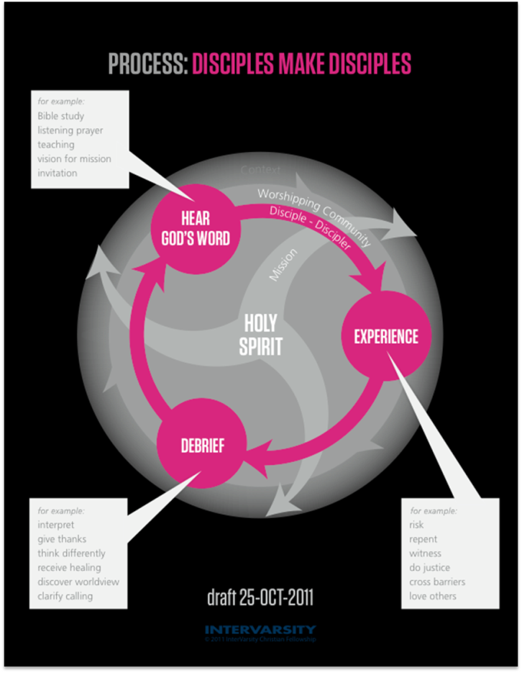

Many thanks for ideas from Kim Porter, Erna Hackett, Sam Rizk, Gary Naumann, Mako Nagasawa, JasonJensen, and Scott Bessenecker.
Many thanks to our InterVarsity staff and student friends from UC Davis, Evergreen College, UC Riverside and Stanford University who tested this on campus.

