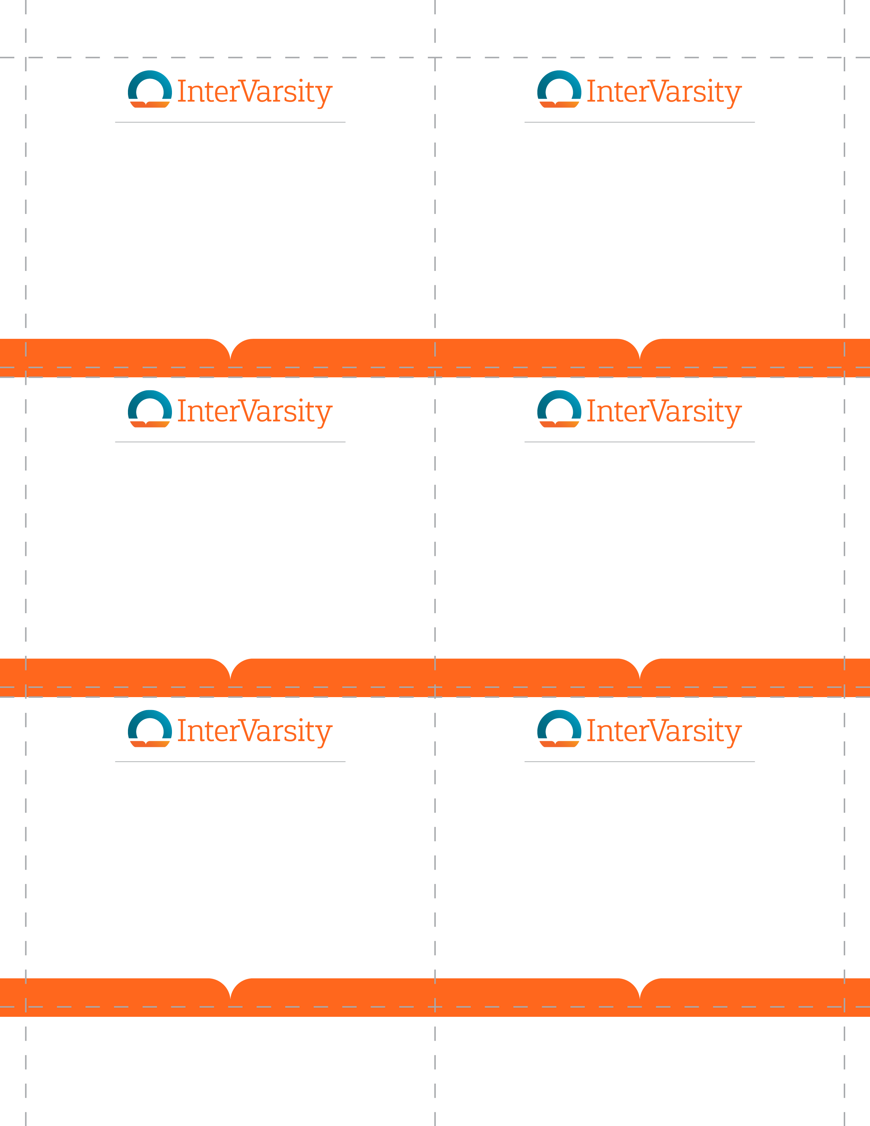

First

Last

position/title

First

Last

position/title

First

Last

position/title

First

Last

position/title

›First

Last

position/title

First

Last

position/title