Proxe Materials & Setup list

MATERIALS
• Pens
• Stickers
• Beyond Colorblind proxe script
• Beyond Colorblind response cards (download or buy from the InterVarsity staff store)
• Beyond Colorblind proxe panels (5)

1 2 3 4 5

SETUP NOTE
Since people tend to take less time on panels 1 & 2, place them side by side on your canopy (see diagram to the right).
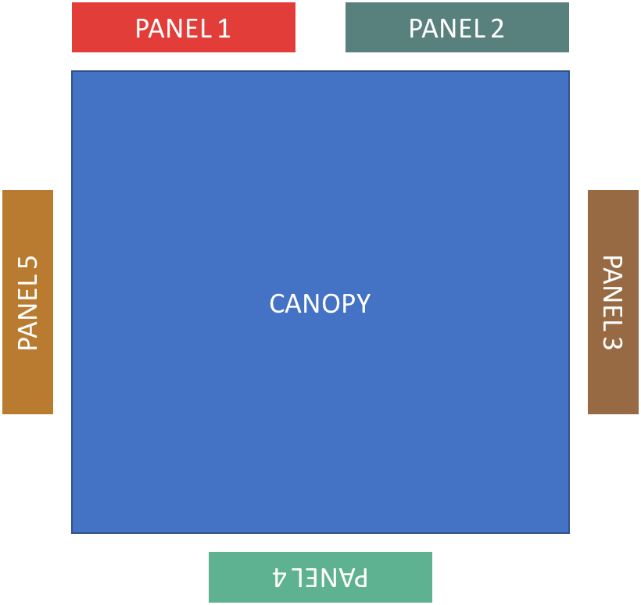

SETUP
Below, you will find detailed instructions on a suggested way to mount and display your proxe panels. Adjust the method according to your own context and resources.

PROXE MATERIALS AND SETUP INSTRUCTIONS
These directions are for one Proxe set-up including a tent, black sheets, and hanging artwork. The total cost of putting one of these Proxes together is about $350-$400.

Materials:
• 10’ x 10’ Sierra II EZ-UP Canopy (approximately $100, but lately Big 5 Sporting
Goods has had them on sale for $80)
• 6-8 bottles of Super Glue ($.97 cents for a 4-pack at Wal-Mart - found in the Hardware
section. However, I found the more expensive Scott Brand at Walgreen’s to be a better
quality glue and faster to work with – it cost about $4 for 2 bottles)
• 4 Flat Twin Black Sheets from Wal-Mart 66 x 96 ($5 - found in the Housewares section)
• Grommet Kit from Wal-Mart ($4.88 - contains 20 grommets - found in the camping
section.
For about the same price, you can buy a grommet kit from Sportsman’s Warehouse
that is better quality)
• 10lb Fishing line (700 yards can be purchased for $2.50 at Wal-mart)
• Velcro squares with sticky backs (Black... a package of four sets of velcro strips 3” x 2”
can be purchased for approximately $5; These can be cut into 24 - 1 inch square sets,
enough for eight Proxe boards. You will also need some extra for the Velcro stripping
on the back of the Proxe boards.)
• 8 Black Foam Boards 32” x 40” from Hobby Lobby ($9 apiece)
• 4 Cord Locks ($.58 cents for a box of 4 at Wal-Mart - found in the camping section)
• 8 Art Posters from 2100 Productions ($60 for the full set of four panels)
• Packaging tape/duct tape
• Tape measure or ruler
• 4 sandbags (usually available for free at local fire stations)
• Dirt or sand (to fill the sandbags)
• String (to attach the sandbags to the tent)

CONSTRUCTION INSTRUCTIONS:

Step 1: Put grommets in the black sheets

You will need to put a grommet in each corner of each of the four sheets. Follow the directions on the grommet kit. It takes about 6 minutes to do 4 grommets. It will take approximately 30 minutes to do all 4 sheets.

Note about putting in the grommets:

One end of the flat sheet already has large doubled-over end. You do not need to fold that to put in a grommet. However, you will need to fold over the opposite end or else the grommet will rip the fabric because the fabric will not be thick enough. Just fold the fabric over enough (about 1 ¼”) to give room for the grommet.

Step 2: Wrap the Proxe Panels onto the black foam boards
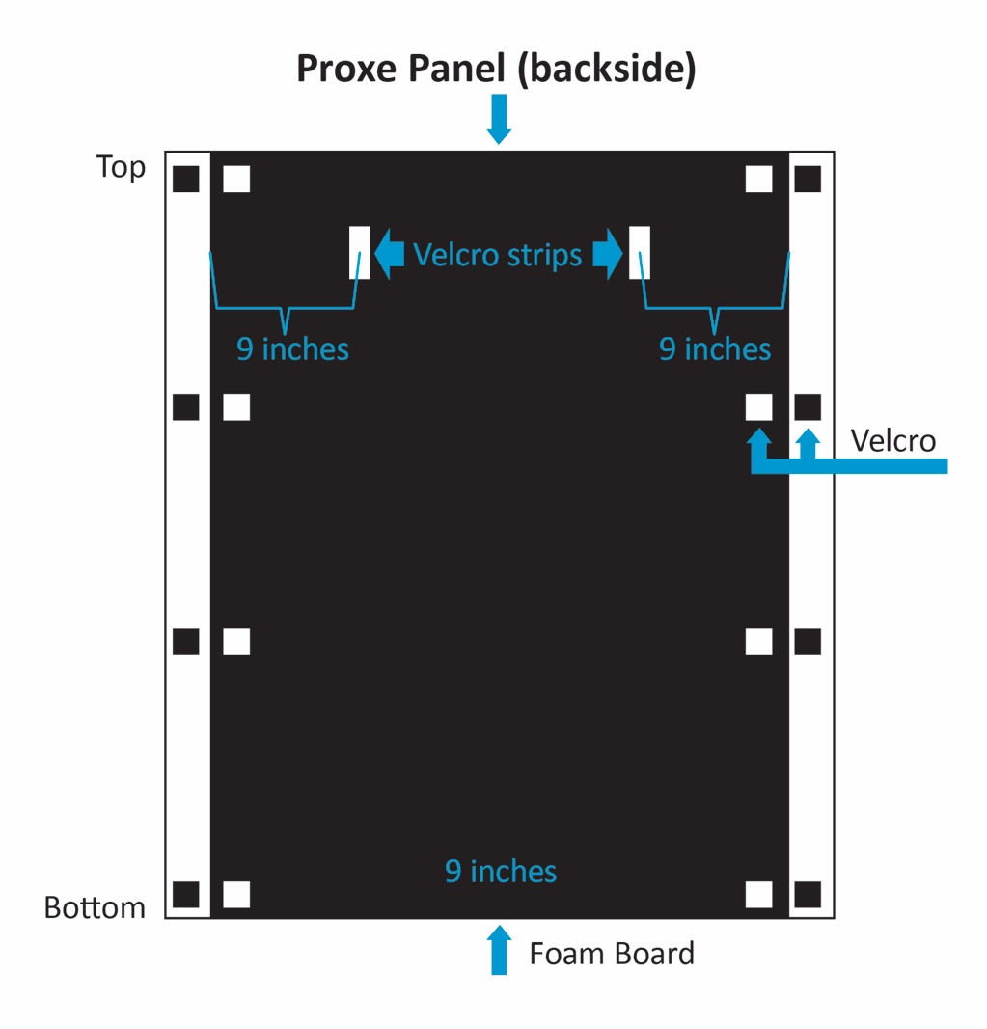
Lay the panel onto a flat table face down. Lay the black foam board on top of it. Line up the side edges. Make sure the top and bottom overlap about 2 inches each. Using squares of Velcro, attach 4 pieces of Velcro to the top and bottom of the panel and also to the board. Wrap the panel pieces around so that the Velcro makes contact and the panel is tightly stretched. If the panel is not stretched enough, just undo the Velcro and move the panel enough to stretch it tight. Repeat for the other 7 panels.

Step 3: Add Velcro strips onto the back of the foam board.

Measure 9” in from either side and add a Velcro strip on the foam board back just below the folded panel. Do an inch strip of hook on one side and an inch strip of loop on the other (the prickly and fuzzy parts of the Velcro).

Step 4: Create the panel hangers

The hangers are a strand of fishing line bookended with Velcro. Cut 24 strands of fishing line 46” long. Place a hook side Velcro face down and put the fishing line on the sticky side with a 12” overlap on one side. Using the 12” overlap, wrap the fishing line around the Velcro twice and then secure by sticking the sticky side of a loop side Velcro onto the back of the previous Velcro. The fishing line can then be tied to itself with 2 square knots for security. Measure 22” from the first Velcro end. Repeat the same procedure on the other end. When you are finished you will have a fishing line 22” long with Velcro squares at either end.

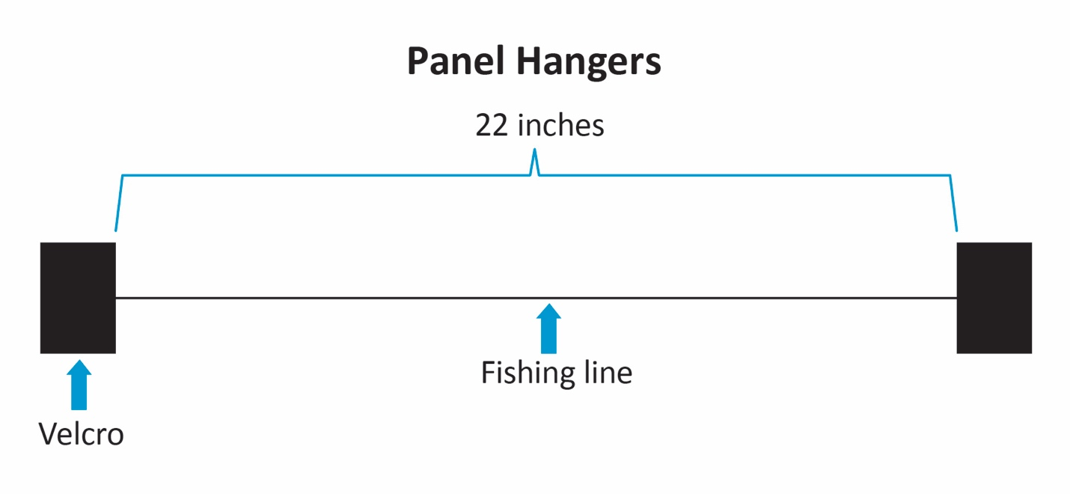

ASSEMBLY INSTRUCTIONS:
Step 1: Put up the tent

Follow the tent’s directions for set-up.

Step 2: Hang the black sheets

Peel the canopy of the tent up to expose the Velcro of the tent. Wrap a mini-bungee once around the outside frame and use both hooks of the bungee to come around the front of the corner leg and hook onto the grommet of the black sheet. Repeat for the other side. If done correctly, the sheet will be taught. Using mini-bungees, attach the bottom grommets to holes that are located in the bottom of the legs.

Step 3: Hang the panels

String the fishing line and Velcro hangers through the pivot points of the tent on each side. There are 2 sides. Using the Velcro, attach the panels to the hangers. Because there are strips on each panel back, the Velcro can be adjusted up or down in order to make sure the panels are even with one another.

Step 4: Tie sandbags to each leg

If you live in a windy area, the tent needs the sandbags. Simply tie a sandbag on each leg to ensure that the tent stays put.

Step 5: Talk to people about Jesus!

FIELD REPAIRS:
Inevitably, something goes wrong with the Proxe when you are on campus. It is helpful to know how to do field repairs just in case.

Field repair kit: super glue, packaging tape, extra shock cord, grommet kit, scissors, knife, extra Velcro, extra fishing line.

Repairing a sheet: You will just have to improvise a bit and put in a new grommet if one pulls out.

Repairing a fishing line hanger: The easiest and simplest method is to make a few extra hangers in advance just in case one breaks.

IN CASE OF WIND:
In case of wind, you will need to secure the panels to the sheets. Attach Velcro to the panel bottom and to the sheet behind it. Attach the two together.

Velcro doesn’t work on a windy day, but the fishing line does!

